Chapter 7, Problem 26.

Express the signals in Fig. 7.104 in terms of singularity functions.

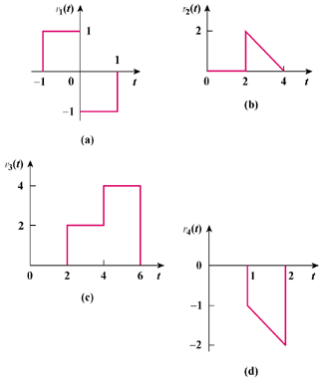

Figure 7.104
For Prob. 7.26.

